Nottingham Behaviour Support Team

Contact us by email: ParentsupportBST@nottinghamcity.gov.uk

Behaviour Strategies and Advice



For Parents and Carers



There are many possible reasons for challenging behaviour and in these extremely difficult times, such challenging behaviour can become more frequent and ultimately even more challenging.

Often it is just because children are tired, hungry, overexcited, frustrated or bored but under the difficult circumstances and new way that we are living now, children are having to adjust to a completely new way of life, which may also add stress and anxiety to an already demanding mix of daily problems.

What are the causes of challenging behaviour?

* Frustration – if your child cannot physically do something and cannot communicate their needs.
* Anxiety and Fear – this can be an issue if your child struggles to cope with change or appears to be frightened of something. This can be particularly relevant at this time.
* Emotion – your child could be unhappy or angry but struggle to express in words how they are feeling. This then results in behaviour.
* Lack of Understanding – some children find it difficult to process instructions or take a long time to work out what you mean.
* Misplaced Attention – it is possible that your child learned that behaviour gets attention and in some cases, any attention is rewarding for them.

Strategies that could help!

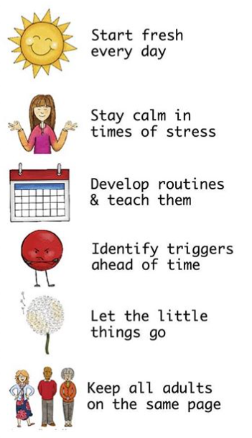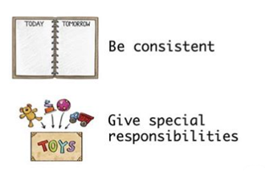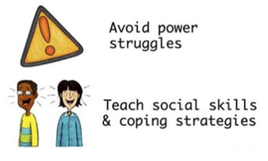

* Build communication –

Let your children know that they can tell you anything and that you understand. Teach them how to recognise when they’re feeling angry, sad, frustrated by:

* Teaching them the symptoms, what happens when they feel a certain way
* How does their body react when they feel a certain way
* What could they do when they feel a certain way, rather than become upset, angry and so on
* What happens before they get upset, angry etc. – can you do something at this point to change what usually happens next?
* 'Wonder aloud’ describe what you see by saying things like 'I can tell that makes you really happy because you have a huge smile on your face'

(Activities in ‘Helping Our Emotions’ can be used to aid this process)

* Give children choices –

Giving choices helps children feel in control and leads to less frustration.

The choices are what you want your child to do; it’s just that you are allowing them to choose.

“You can go to bed now and…”

Or

“You can stay up until 8 but…”

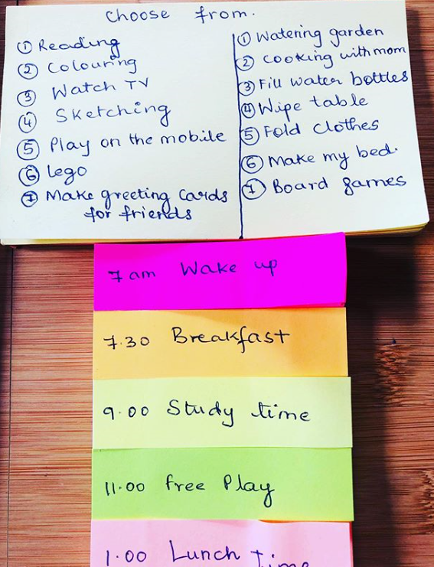

* Develop a routine together –

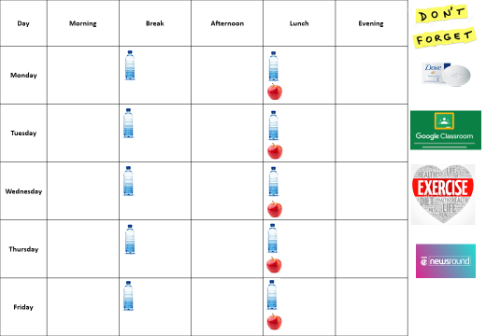Whilst making this together, allow children to take ownership of the routine you create. Give them the opportunity to choose from a range of activities (as below) but also activities of their own.

* Share your time –

Try to make time to play, or do an activity together. Often children will show an unwanted behaviour choice as a way of seeking attention, when actually it might be that at that moment, they need your attention. So set a time in your day that they can have it or share it.







* Include exercise in your daily routine –

Exercise is a really effective way of relieving frustration and chasing away sad or angry emotions.

Studies have shown that exercise helps by:

Relieving stress and anxiety.

Increase the production of endorphins, which are known to help produce positive feelings.

In addition, it can help relaxation and sleep.

* Try to stay positive – we know that is sometimes easier said than done!

Try to state things in a positive way by re-directing children into making positive behaviour choices and once they have done this reward them with praise or affection.

For example.

Sibling fallouts – which could probably be on the increase at the moment, can be re-directed from a negative into a positive

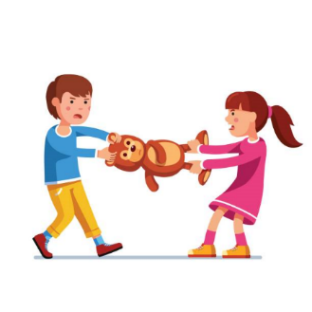

When a child shows challenging behaviour regularly, it is easy to overlook the things they do well. Try to catch your child when they do something well and tell them how pleased you are about what they've done. You can let your child know when you're pleased by giving them attention, a hug or smile etc.

Giving children jobs to do is a great way of giving them the chance to do something well and consequently the chance for praise.



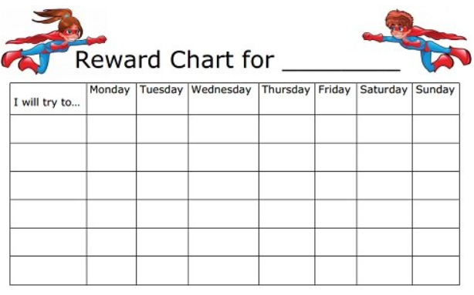

* Be consistent –

Tell everyone involved about how you are reacting to any challenging behaviour and ask them to do the same.

*Children can get very confused if they are receiving mixed messages, which can lead to their behaviour becoming worse.*

* Look after yourself –

Being a parent is hard work.

The things that are in this booklet are not always easy to carry out.

Parents are often so busy thinking about everyone else that they forget about themselves.

Make time to relax – put your feet up, meet up with friends (electronically), exercise or just try and have a good night’s sleep.

Good luck and stay safe!