Name
Tutor

Revision Organiser
Plan your revision giving enough time to each qualification.
triple science = triple time!
PLAN in your breaks

Make sure you keep doing the things you love as well, especially exercise

REVISION TOP TIPS
The best use of time is in 45-minute bursts:
- 15 minutes to make a resource
- 10 minutes revise
- 5 minute test
- Revise again for 10 minutes
- 5 minutes test
Make revision resources such as flashcards, clocks and quizzes and test yourself

Work in small manageable time slots

Don’t be tempted to spend all your time on things you find the easiest
Be ACTIVE in your learning, just reading or watching isn’t enough

Useful links and websites

Here are some additional online revision resources you can use if you want to.

All Subjects | BBC Bitesize | https://www.bbc.co.uk/bitesize/secondary
English | Seneca  Mr Bruff  No Fear Shakespeare Spark notes | https://senecalearning.com  www.youtube/user/mrbruff  https://www.sparknotes.com/shakespeare/
Maths | MathsWatch  Corbett Maths 5 a day | https://mathswatch.co.uk  https://corbettmaths.com/
Maths | Hegarty Maths | https://hegartymaths.com/
Science | Educake  23 equations app  Free Science lessons (youtube) | https://www.educake.co.uk/forstudents  https://23equations.com/  https://www.youtube.com/channel/UCqbOeHaAUXw9Il7sBVG3_bw
Geography | Seneca | https://senecalearning.com  https://www.bbc.co.uk/bitesize/examspecs/zy3ptyc  https://geographycat.co.uk/
Spanish | Activelearn  memrise  Quizlet  BBC bitesize  AQA | https://www.pearsonactivelearn.com/app/home  https://www.memrise.com/  https://quizlet.com/en-gb  https://www.bbc.co.uk/bitesize/secondary  https://www.aqa.org.uk/subjects/languages/gcse
PE | Everlearner | https://www.theeverlearner.com/
Catering | Use GCSEbitesize for content, short video clips and tests.  Use GCSEpod for short podcasts on most if the topics. | https://www.bbc.co.uk/bitesize/subjects/zdn9jhv  https://members.gcsepod.com/shared/podcasts#6006/6013

Additional Study Opportunities: Autumn term
The sessions below are available for you to attend now. This list will be reviewed regularly.

Who | When | Where | What | Why
KS4 | Lunchtime | A57 | Study Support | Study support for all subject areas
YEAR 11 | Every day 3:15 – 4:30 | A57 | Study Lounge | Study support for all subject areas
Physics | Thursday 3:15 - 4:00 |  | GCSE Physics revision | Exam practice for GCSE Physics (triple only)
Physics | Friday Lunchtime |  | GCSE Physics 8/9 | Targeted exam practice for grade 8/9 students
Media | Monday 12:45 – 1:15 | A49 | Media extra | Media room open for media students to work on NEA and exam work
History and Geography | Monday 3:30 - 4:15 | R10/R11 | GCSE Humanities support | Support with content, exam practice/skills
Chemistry | Friday 3:15 – 4:00 |  | GCSE Chemistry Revision | Exam practice for GCSE chemistry (triple only)
Maths | Monday 3.15 – 4.00  Wednesday Lunchtime | B15 | GCSE Maths Support | Help with topics, support with exam practice
©

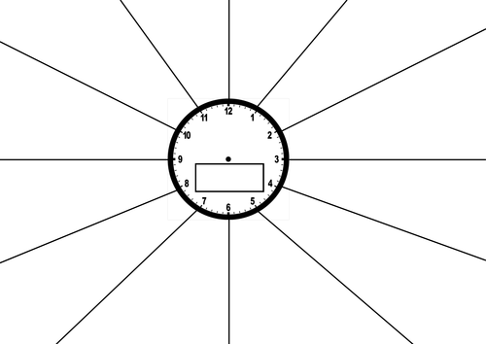
Revision planner
Week beginning: ________________________________
Subject | What are you doing? | Time | When did you do it? | Targets for next time

Week beginning: ________________________________
Subject | What are you doing? | Time | When did you do it? | Targets for next time

Week beginning: ________________________________
Subject | What are you doing? | Time | When did you do it? | Targets for next time

Week beginning: ________________________________
Subject | What are you doing? | Time | When did you do it? | Targets for next time

Week beginning: ________________________________
Subject | What are you doing? | Time | When did you do it? | Targets for next time

Week beginning: ________________________________
Subject | What are you doing? | Time | When did you do it? | Targets for next time

Week beginning: ________________________________
Subject | What are you doing? | Time | When did you do it? | Targets for next time

